1. Collections in SCALA  
   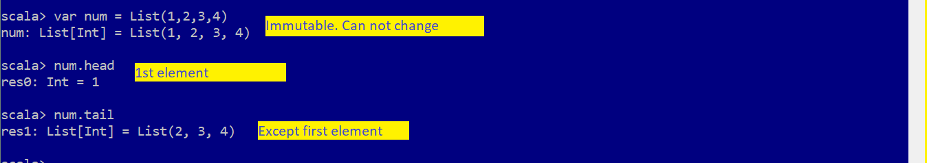

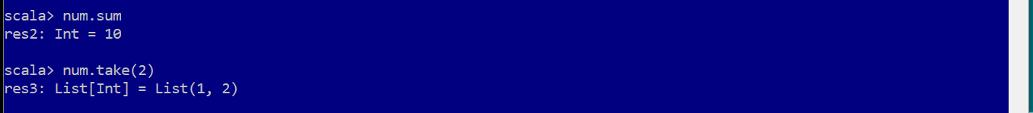

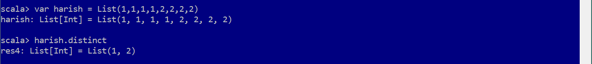

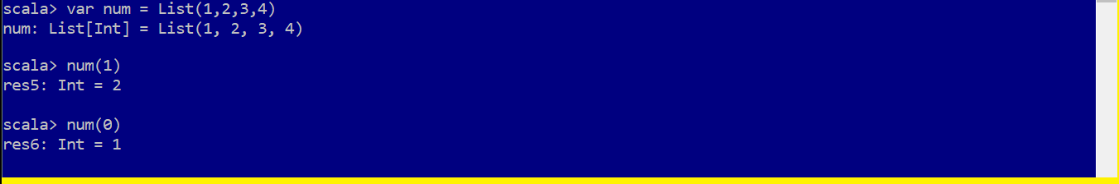

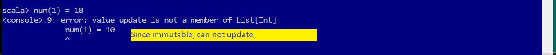

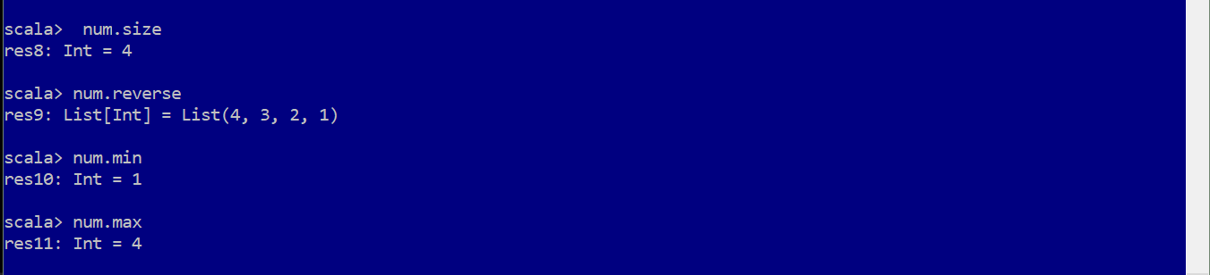



1. Array

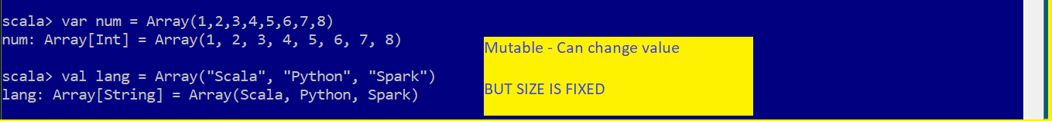

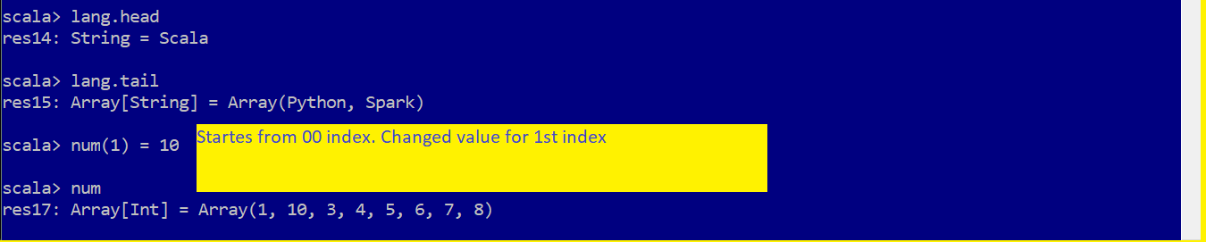

* Mutable array – Can increase SIZE

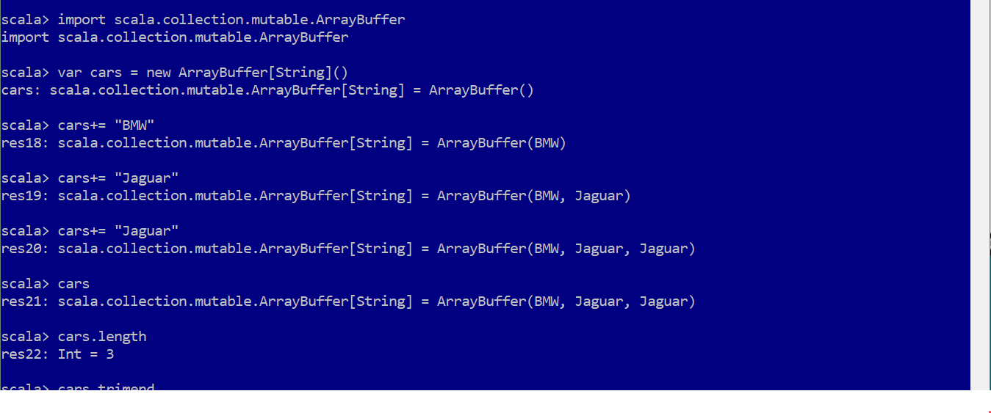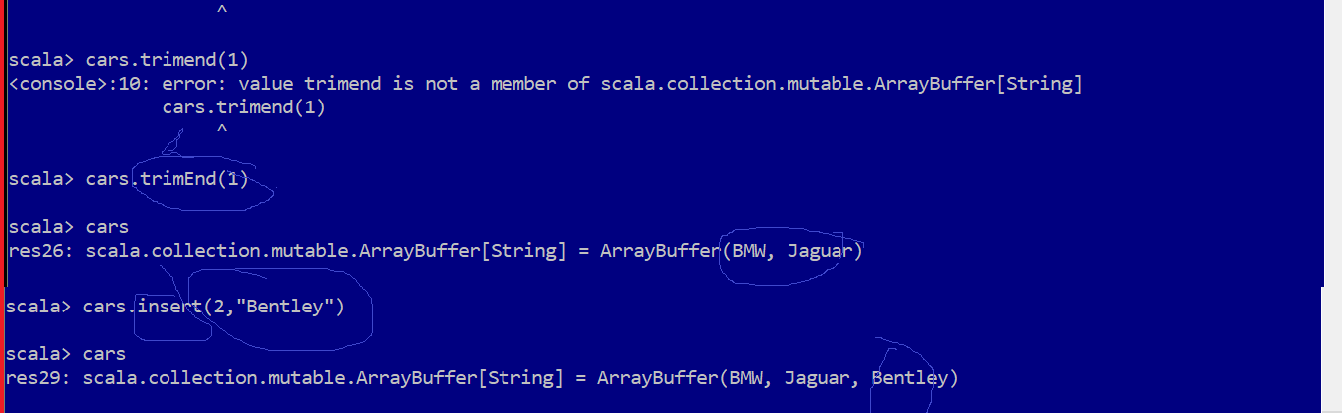

1. Anonymous Function

MAP – Most used pre defined higher order function

X inside MAP function is anonymous function

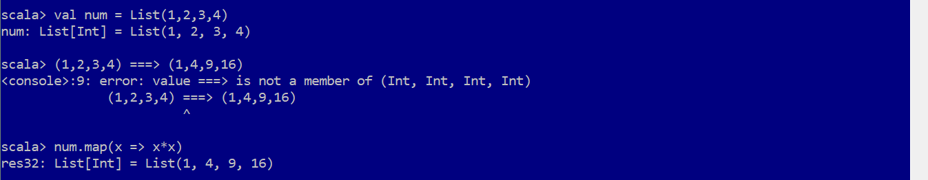

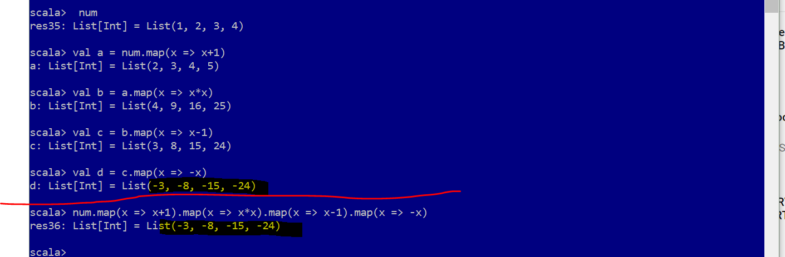

Above shows same thing by 2 different way using map function.

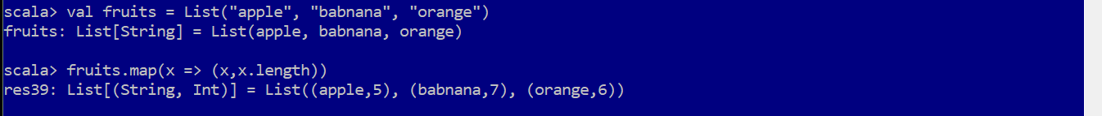



1. Sample question to use map, filter

